[1 mark] Consider the following class:  
public class Singleton {  
 private static Singleton instance = null;  
 public static Singleton getInstance() {  
 if (instance == null)  
 instance = new Singleton();  
 return instance;  
 }  
 private Singleton() { }   
 …  
How to create an instance of the Singleton class?

Singleton s = Singleton.getInstance();

Singleton s = new Singleton();

Singleton s = new Singleton.getInstance();

Singleton s = setInstance();

Singleton s = getInstance(Singleton);

[1 mark] Which of the following statements is true?

A class variable of a class is shared by all of its instances.

An instance variable of a class is shared by all of its subclasses.

A class method of a class can be inherited by all of its superclasses.

A class variable of a class can be inherited by all of its superclasses.

All statements are TRUE.

[1 mark] In UML the third box of a class representation normally contains _________.

the names of operations that can be performed

name of the class

name of attributes of the class

name of the package

name of the interface

[1 mark] Inheritance explains that a class can have all the features of another class called the ____ part and can also have its own features, called the _________.

parent, derived part

super, normative part

derived, incremental part

derived, super class

normal, super part

[1 mark] Inheritance is an implementation of the _________ relationship.

generalization

aggregation

accumulation

composition

none of the others

[1 mark] Which kinds of variables are used to hold information that generally applicable to all instances of the class?

Class variable

Global variable

Temporary variable

Instance variable

Local variable

[1 mark] Invoking super.move() is another way of saying

start looking for the move method in the next class higher up.

use the move method from the current class you’re in.

start looking for the move method in a class that is two classes above.

start looking for the method in the class you’re in, then look for the method in the class that is higher in the hierarchy.

start looking for the move method one class down.

[1 mark] Polymorphism is defined as...

overloading methods in a super class.

objects responding to the same message (method name) in different ways.

a logical representation of the problem.

when a subclass has access to methods in the superclass.

when a superclass has access to methods in the subclass.

[1 mark] Which of the following statements is FALSE?

A class may extend several classes (Multiple inheritance) forming a new class.

An object is always passed by reference to a method.

A static method may be called without reference to an instance of the class.

An array is always passed by reference to a method.

You can override a base class method in a derived class.

[1 mark] Which of the following statements is TRUE?

From a constructor you can call the classes superclass constructor.

A constructor is inherited.

A class must have a public constructor.

The garbage collector is used to get rid of program errors.

You can place any subclass constructor code ahead of its superclass constructor call.

[1 mark] A use case models the ____________between a system and the environment in which the information system operates.

relationship

interaction

choices

current environment

behaviours

[1 mark] Given the following code:  
public interface AQuestion {   
 public abstract void someMethod();   
}  
A Class implementing this interface

should have someMethod which must necessarily be public.

should Necessarily be an abstract class.

should have the method public abstract void someMethod();

should have the method public int someMethod()

should have the method void someMethod() which could be protected.

[1 mark] Consider the following two classes:  
package p1;  
public class Protection {  
 int n_default = 1;  
}  
  
package p2;  
class P2Derived extends p1.Protection {  
 public void method() {  
 System.out.println("n_default=" + n_default);  
 }  
 public static void main(String[] args) {  
 P2Derived b = new P2Derived();  
 b.method();  
 }  
}  
What will happen when you attempt to compile and run the main method of P2Derived class?

Compile Time error

Output: 1

Runtime error

Unknown

Output: 0

[1 mark] Sequence diagrams:   
i. show a succession of interactions over time.   
ii. illustrate processing described in use case scenarios.   
iii. are derived from use case analysis.   
iv. show relationship between classes

i, ii and iii

i only

ii and iii

iv only

i and iv

[1 mark] An inner class created inside a method can access   
i. any local variables of a method that contain an inner class.   
ii. any instance variables of the enclosing class   
iii any final variables of the enclosing class or a method that contain an inner class.

ii and iii

i only

ii only

iii only

i, ii, and iii

[1 mark] Consider the following classes:  
interface A {  
 String s1 = "A";  
 String m1();   
}  
interface B implements A {  
 String s1 = "B";  
 String m1();   
}  
class C implements B {  
 public String m1() {return s1;}  
 public static void main(String[] args) {  
 A a = new C();  
 System.out.print(a.m1());  
 }  
}  
What is the result of attempting to compile and run the program?

Output: A

Output: B

Compile-time error.

Run-time error.

None of the others.

The following THREE questions are based on the following UML

ClubBarbie

+ClubBarbie(String name, String clubname, int ID)

+void doSomething()

+void passOut()

-String clubName

-ID fakeID

SportyBarbie

+SportyBarbie(String name, String sport)

+void doSomething()

-String sportName

Barbie

+Barbie(String name)

+void abstract doSomething()

+void move()

-String name

BeachBarbie

+BeachBarbie(String name, String beachname)

+void doSomething()

-String beachName

[1 mark] Consider the following code fragment:  
BeachBarbie bb = new BeachBarbie(“Susan”, “Half Moon Bay”);   
bb.move();  
Which of the following statements is true?

It will use move() from Barbie.

This code will break; since BeachBarbie has no move method.

It will use move() from BeachBarbie.

It will use move() from Robot.

None of the others.

[1 mark] Which of the following code is a valid constructor of the SportyBarbie class?

public SportyBarbie(String name, String sport){   
 super(name);  
 this.sportName = sport;  
}

public SporytBarbie(String name) { super(sport); }

public SportyBarbie(String name, String sport){   
 super();  
 this.sportName = sport;  
}

public SportyBarbie(String name, String sport){   
 this.sportName = sport;  
 super(name);  
}

public SporytBarbie(String name) { this.sportName = sport;}

[1 mark] What will happen when you attempt to compile and run the following code fragment?  
Barbie b = new ClubBarbie();  
b.passOut();

Compile time error.

Compiled successfully and executed the passOut method of ClubBarbie.

Runtime error; since BeachBarbie has no passOut method

Unknown.

Compiled successfully and executed the passOut method of Barbie.

The following **FOUR** questions are based on the following classes.

class A {

protected int count;

protected static int i = 1;

public A() {

count = i++;

}

public String getString() {

return "a"+count;

}

public void n() {}

}

class B extends A {

public String getString() {

return super.getString()+"b";

}

public void j() {}

}

class C extends A {

public String getString() {

return super.getString()+"c";

}

public void k() {}

}

public class Q1 {

public static void main(String[] args) {

A a1 = new A();

B b1 = new B();

C c1 = new C();

A d1 = c1;

...

}

}

[1 mark] What is the output of the following statement?  
System.out.println(b1.getString());

a2b

a1b

a0b

ab

b

[1 mark] What is the output of the following statement?  
System.out.println(d1.getString());

a3c

a1bc

a0bc

c

a3bc

[2 marks] Which of the following statements, when added to the bottom of the main method, would be ILLEGAL at COMPILE-time?

b1= (A) b1;

a1 = b1;

b1 = (B) a1;

a1 = c1;

c1 = (C) a1;

[2 marks] Which of the following statements, when added to the bottom of the main method, would be LEGAL at COMPILE-time?

((B)a1).j();

((C)a1).j().k();

B(a1).k();

((B)a1).k();

((A)a1).j();

[1 mark] Consider the following string representing an URL: “<http://www.acme.com:8080/ref/host/games.html#DOWNLOAD>”. Which of the following statements is TRUE?

“www.acme.com” represents the host part

“games.html” represents the protocol part

“ref” represents the reference part

“DOWNLOAD” represents the file part

“8080” represent the IP number

[2 marks] Consider the following code snippet from a Client that uses an UrlConnection:  
URL yahoo = new URL("http://www.yahoo.com/default.html");  
URLConnection yc = yahoo.openConnection();  
BufferedReader in = new BufferedReader(new InputStreamReader(yc.getInputStream()));  
Which of the following statements is FALSE?

yahoo.openConnection() downloads the HTML page referred to by the given URL

yc.getInputStream() returns an input byte stream that reads from the yc connection

**new** InputStreamReader(…) builds a bridge from byte streams to character streams

**new** BufferedReader(…) builds an efficient reader of characters and lines

yahoo.openConnection() builds a connection to the remote service referred to by the given URL

[2 marks] Consider the following fragments of an HTTP request/response pair:  
GET /test.htm HTTP/1.1  
User-Agent: Mozilla/4.0 (…)  
Host: localhost:8090  
  
HTTP/1.1 200 OK  
Server: ASP.NET Development Server/9.0.0.0  
Date: Thu, 10 Oct 2008 05:08:50 GMT  
Content-Type: text/html  
Content-Length: 109  
  
<html>  
<head><title>TEST</title></head>  
<body>  
<h1>This is</h1>  
<h2>a text file.</h2>  
</body>  
</html>  
Which of the following statements is TRUE?

Content-Length: 109 indicates the length of the <html> … </html> payload

HTTP/1.1 200 OK indicates a server error with code 200

Content-Length: 109 indicates the longest URL acceptable to this server

User-Agent: Mozilla/4.0 (…) indicates a download request of the Mozilla/4.0 HTML page

GET /test.htm HTTP/1.1 indicates an HTTP POST request to update the test.htm page

[1 mark] Which of the following statements is FALSE?

ServerSocket.accept() automatically forks a new Thread

ServerSocket.accept() blocks until a connection is made

ServerSocket.accept() returns a Socket

**new** ServerSocket(4444) creates a server socket, bound to port 4444

**new** Socket(“www.acme.com”, 4444) creates a client socket and connects it to port 4444 on host “www.acme.com

[1 mark] Which of the following statements is FALSE?

Runnable class implements Thread interface

Every Runnable object has a run() method

Every Thread object has a run() method

Threads can have names, returned by the getName() method

A Thread’s sleep period can be interrupted

[1 mark] Which of the following statements is FALSE?

new Thread.run() starts executing the task indicated by Thread’s own start()

new Thread().start(); starts executing the task indicated by Thread’s own run()

new Thread(*runnable*).start(); starts executing the task indicated by *runnable*’s run()

Executor.execute(*runnable*) will execute *runnable*’s run(), sometime in the future

Executors.newFixedThreadPool(10) creates a thread pool that reuses 10 threads

[1 mark] Which of the following statements is FALSE?

A SwingWorker’s process() method is run by a background thread

A SwingWorker’s done() method is run by the GUI thread

A SwingWorker’s process() method receives one or more chunks send by the publish() method

A SwingWorker’s doInBackground() method can explicitly override, by @Override, the corresponding method from the superclass

The GUI cannot be directly updated by code in SwingWorker’s doInBackground() method

[1 mark] Which of the following tasks would you typically assign to the GUI thread?

Display a message box

Number crunching code

Perform IO via sockets

Execute SQL database operations

Loading large files

[1 mark] Consider an integer counter C, with initial value 20, and three threads updating it, roughly at the same time, in a context without any kind of mutual exclusion: (1) thread #1 will run the code C = C + 10; (2) thread #2 will run the code C = C + 10; (3) thread #3 will run the code C = C - 10. Which of the following statements is FALSE?

The final value of C can be 50

The final value of C can be 40

The final value of C can be 30

The final value of C can be 20

The final value of C can be 10

[1 mark] How does BlockingQueue handle operations that cannot be immediately satisfied? Which of the following statements is FALSE?

By changing the thread status to daemon

By throwing an exception

By returning a special value (boolean or null)

By blocking indefinitely until the operation can succeed

By blocking for a given time limit before giving up and returning a special value

[2 marks] Which of the following statements is TRUE?

A critical region protected by **synchronized** statements provides only one waiting queue for all threads

A critical region protected by an explicit Lock, such a RentrantLock, provides only one waiting queue for all threads

Concurrency management with **synchronized** statements is the most efficient in all contention scenarios

Concurrency management with explicit Locks, such as RentrantLock, is the most efficient in all low contention scenarios

Optimistic concurrency management with compareAndSet is the most efficient in all high contention scenarios

Use the data model below for the following TWO questions:

**A**

**R-AG**

**G**

1

N

**R-GHI**

**H**

N

M

**B**

**C**

**D**

**E**

**F**

**I**

O

Figure 1 – Entity Relationship Diagram

[3 marks]The ERD presented in Figure 1 corresponds in the relational model to a **maximum** of:

11 Tables, 11 Entity constraints, 10 Referential integrity constraints

10 Tables, 10 Entity constraints, 5 Referential integrity constraints

7 Tables, 7 Entity constraints, 6 Referential integrity constraints

10 Tables, 10 Entity constraints, 9 Referential integrity constraints

None of the other answers are correct.

[3 marks]The ERD presented in Figure 1 corresponds in the relational model to a **minimum** of:

5 Tables, 5 Entity constraints, 4 Referential integrity constraints

6 Tables, 6 Entity constraints, 5 Referential integrity constraints

6 Tables, 6 Entity constraints, 6 Referential integrity constraints

7 Tables, 7 Entity constraints, 6 Referential integrity constraints

None of the other answers are correct.

[3 marks]What is the ER diagram that best represents the situation detailed below?  
Architects Inc. would like to store information about its branches, clients, client projects, and staff. The company has numerous branches, specialising in different types Architecture (e.g. Interior, Landscape, Architectural Engineering, Environmental Design), and on every branch both administrative staff and architects work. Only architects can be allocated to client projects. Architects also specialise in one or more types of Architecture, and therefore can only be allocated to client projects within their area(s) of specialisation. A Branch can also only look after client projects in its area(s) of specialisation. The information about staffs’ dependents is also stored, and only a single staff is associated to a dependent.  
Architects can work concurrently in no more than seven client projects; however junior architects can only work on a single project at a time. Senior architects can be allocated to as many client projects as necessary.

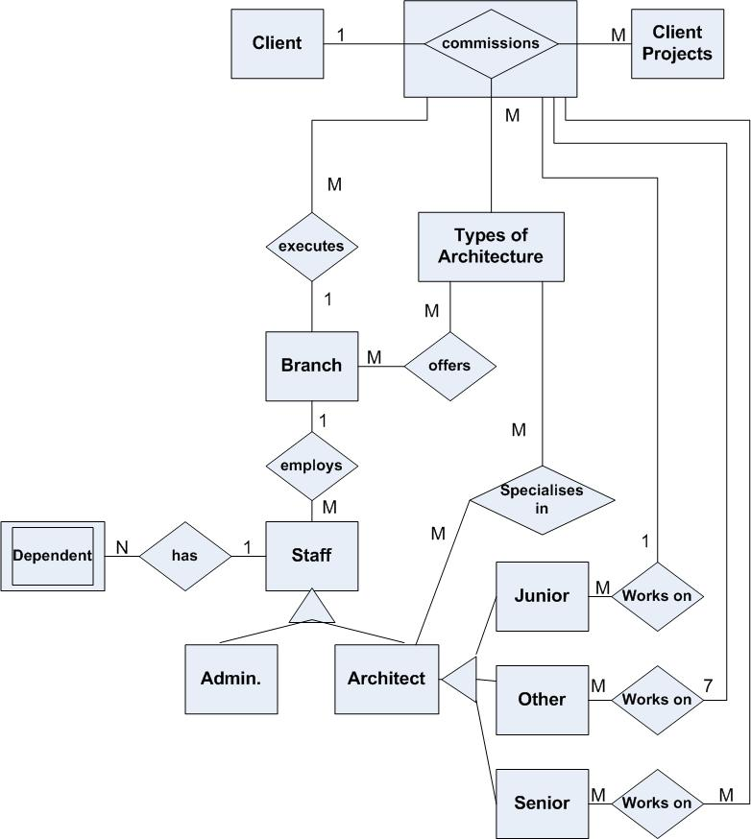

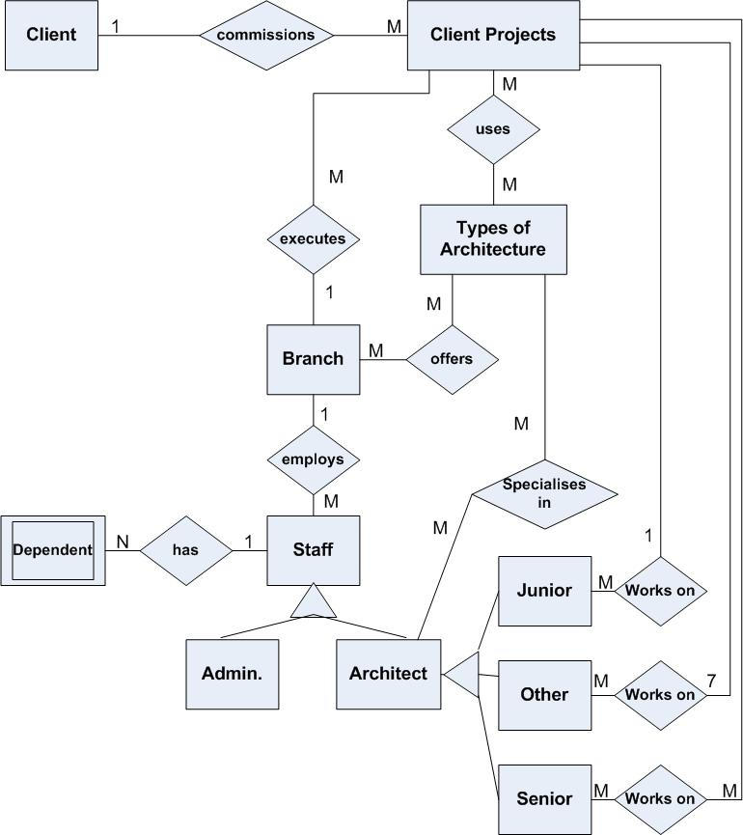

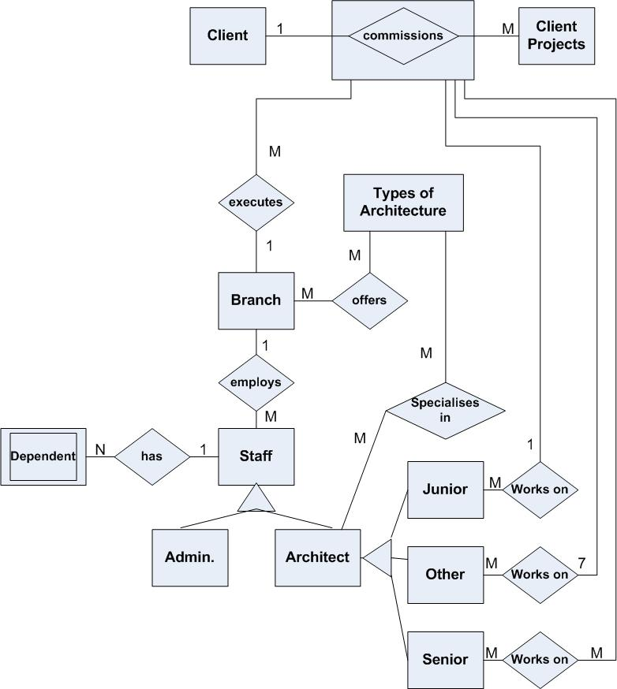

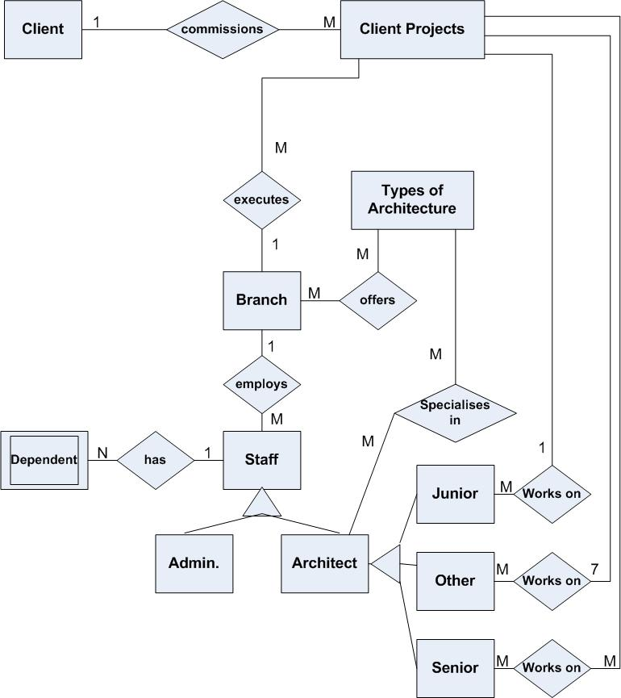

None of the other diagrams are correct

The following **FOUR questions** are all based on the following three tables:

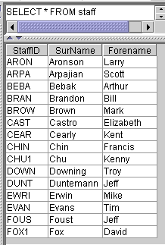Staff table

**project table**

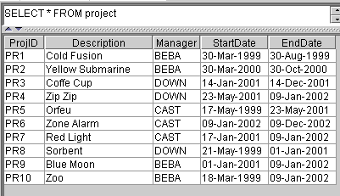

**staffproject table**

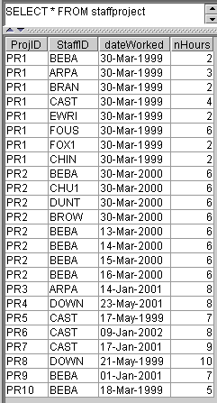

Primary key for staff is StaffID

Primary key for project is ProjID

Primary key for

staffproject is StaffID + ProjID + DateWorked

[3 marks]What is the SQL statement that answers the following question: What are the full names of those staff who work in the project “Yellow Submarine”?

Select distinct Forename, Surname From staff, project, staffproject Where StaffID = StaffID AND ProjID = ProjID AND Description = “Yellow Submarine”

Select distinct Forename, Surname From staff, project, staffproject   
Where StaffID = staffproject.StaffID AND ProjID = staffproject.ProjID AND   
Description = “Yellow Submarine”

Select distinct Forename, Surname From staff, project, staffproject Where staff.StaffID = staffproject.StaffID AND project.ProjID = staffproject.ProjID AND   
project.Description = “Yellow Submarine”

Select * From staff, project, staffproject   
Where StaffID = staffproject.StaffID AND ProjID = staffproject.ProjID AND Description = “Yellow Submarine”

None of the other answers are correct

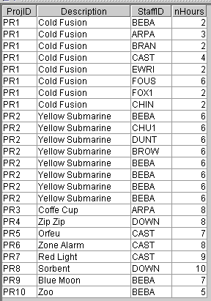[3 marks]What is the SQL statement which generates the following output?

Select ProjID, Description, StaffID, nHours   
From project, staffproject   
Where ProjID = staffproject.ProjID

Select project.ProjID, Description, StaffID, nHours   
From project, staffproject   
Where project.ProjID = staffproject.ProjID

Select StaffID, Description, ProjID, nHours   
From project, staffproject   
Where project.ProjID = staffproject.ProjID

Select project.ProjID, Description, StaffID, nHours   
From project, staffproject   
Where ProjID = staffproject.ProjID

None of the other answers are correct

[2 marks] Given the following Java application  
import java.sql.*;  
public class ExamJDBC1 {  
 public static void main(String args[]) {  
 String username = "username1";  
 String password = "password";  
 String url = "jdbc:mysql://localhost/Database";  
 ResultSet result, result1;  
 try {  
 Class.forName("com.mysql.jdbc.Driver");  
 System.out.println("Driver loaded");  
 }  
 catch (Exception E) {  
 System.err.println("Unable to load driver.");  
 E.printStackTrace();  
 }  
 try {  
 Connection conn = DriverManager.getConnection  
 (url, username, password);  
 Statement stmt= conn.createStatement();  
 result1 = stmt.executeQuery("SELECT distinct * FROM staffproject   
 WHERE nHours > 5 AND nHours < 11 ");  
 ResultSetMetaData metaData = result1.getMetaData();  
 int columnCount = metaData.getColumnCount();  
 for (int i=1; i<=columnCount; i++) {  
 if (i > 1) System.out.print('\t');  
 System.out.print(metaData.getColumnLabel(i));  
 }  
 System.out.println();  
 result = stmt.executeQuery("SELECT distinct * FROM staffproject   
 WHERE nHours > 6 AND nHours < 11 ");  
 while (result.next()) {  
 for (int i=1; i<= columnCount; i++) {  
 if (i>1) System.out.print('\t');  
 System.out.print(result.getString(i));  
 }  
 System.out.println();  
 }  
 result.close();  
 conn.close();  
 }  
 catch (SQLException E) {  
 System.out.println("SQLException: " + E.getMessage());  
 System.out.println("SQLState: " + E.getSQLState());  
 System.out.println("VendorError: " + E.getErrorCode());  
 }  
 }  
}  
The Java application displays _______ rows from its result set:

7 rows

16 rows

12 rows

9 rows

None of the other answers are correct.

[2 marks] _______________________ is a feature provided by Relational Database Management Systems that stops users or applications from entering inconsistent data representing the relationship between two Entity Types (note: one Entity type, although not common, is also applicable here):

Referential Integrity constraint

Entity Integrity constraint

Reciprocity Integrity constraint

Primarily key constraint

None of the other answers are correct.

[2 marks]If you do **NOT** wish to use a pre-compiled SQL statement or stored procedures, which of the following statement type should be used?

Statement

CallableStatement

PreparedStatement

ContentiousStatement

None of the other answers are correct.

[2 marks]What method should **NEVER** be used if you are expecting to obtain a ResultSet as the result of executing an SQL statement?

executeUpdate()

executeQuery()

execute()

executeInsert()

None of the other answers are correct.

Given the following Java application  
import java.sql.*;  
public class ExamJDBC2 {  
 public static void main(String args[]) {  
 String username = "username";  
 String password = "pass";  
 String url = "jdbc:mysql://localhost/Pets";  
 ResultSet result, result1;  
 try {  
 Class.forName("com.mysql.jdbc.Driver");  
 System.out.println("Driver loaded");  
 } catch (Exception E) {  
 System.err.println("Unable to load driver.");  
 E.printStackTrace();  
 }  
 try {  
 Connection conn = DriverManager.getConnection  
 (url, username, password);  
 Statement stmt= conn.createStatement();  
 result = stmt.executeQuery("SELECT * FROM staff");  
 result = stmt.executeQuery("SELECT * FROM staffproject");  
 result = stmt.executeQuery("SELECT * FROM project");  
 ResultSetMetaData metaData = result.getMetaData();  
 int columnCount = metaData.getColumnCount();  
 for (int i=1; i<=columnCount; i++) {  
 if (i > 1) System.out.print('\t');  
 System.out.print(metaData.getColumnLabel(i));  
 }  
 System.out.println();  
 result = stmt.executeQuery("SELECT * FROM staff");  
 result1 = stmt.executeQuery("SELECT * FROM staff");  
 while (result.next()) {  
 for (int i=1; i<= columnCount; i++) {  
 if (i>1) System.out.print('\t');  
 System.out.print(result.getString(i));  
 }  
 System.out.println();  
 }  
 result.close();  
 conn.close();  
 } catch (SQLException E) {  
 System.out.println("SQLException: " + E.getMessage());  
 System.out.println("SQLState: " + E.getSQLState());  
 System.out.println("VendorError: " + E.getErrorCode());  
 }  
 }  
}

[3 marks]What is the output generated by the execution of the code?

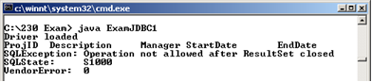

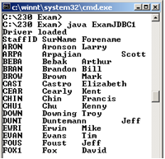

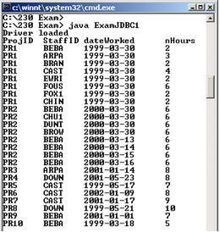

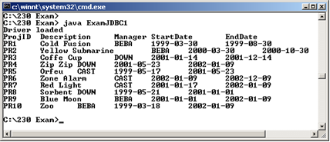

None of the other answers are correct.